Nama : Herly Herdiansyah Saputra
NIM : 055716397
Izin menjawab diskusi 4

Soal
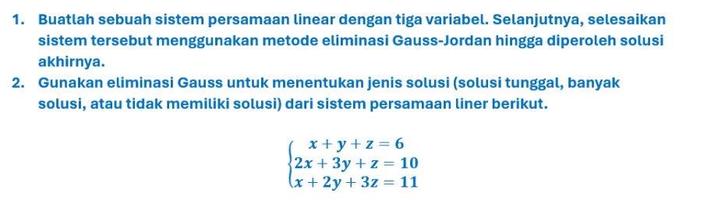

Jawaban
- Sistem Persamaan :
- $x+y+z=6$
- $2x-y-z=3$
- $x+2y-z=2$
Mengubah matriks augmentasi
$$\left(\begin{matrix}1 & 1 & 1 & | & 6 \\ 2 & -1 & 1 & | & 3 \\ 1 & 2 & -1 & | & 2\end{matrix}\right)$$

Eliminasi Gauss
$$R_{2}-2R_{1}→R_{2}$$
$$R_{3}-R_{1}→R_{3}$$
$$\left(\begin{matrix}1 & 1 & 1 & | & 6 \\ 0 & -3 & -1 & | & -9 \\ 0 & 1 & -2 & | & -4\end{matrix}\right)$$

Menukar $R_{2}$ dan $R_{3}$, mengalikan $R_{3}$ dengan -1
$$\left(\begin{matrix}1 & 1 & 1 & | & 6 \\ 0 & 1 & -2 & | & -4 \\ 0 & 3 & 1 & | & 9\end{matrix}\right)$$
$R_{3}-3R_{2}→R_{3}$: $\left(\begin{matrix}1 & 1 & 1 & | & 6 \\ 0 & 1 & -2 & | & -4 \\ 0 & 0 & 7 & | & -21\end{matrix}\right)$
${\frac{1}{7}R}_{3}→R_{3}$: $\left(\begin{matrix}1 & 1 & 1 & | & 6 \\ 0 & 1 & -2 & | & -4 \\ 0 & 0 & 1 & | & 3\end{matrix}\right)$

Membuat Matriks Identitas
$$R_{2}+2R_{3}→R_{2}$$
$$R_{1}-R_{3}→R_{1}$$
$$\left(\begin{matrix}1 & 1 & 0 & | & 3 \\ 0 & 1 & 0 & | & 2 \\ 0 & 0 & 1 & | & 3\end{matrix}\right)$$
$$R_{1}-R_{2}→R_{1}$$
$$\left(\begin{matrix}1 & 0 & 0 & | & 1 \\ 0 & 1 & 0 & | & 2 \\ 0 & 0 & 1 & | & 3\end{matrix}\right)$$

Solusi Akhir: $x=1,y=2,z=3$

- Sistem Persamaan :
- $x+y+z=6$
- $2x+3y+z=10$
- $x+2y+3z=11$
Matriks Augmentasi:
$$\left(\begin{matrix}1 & 1 & 1 & | & 6 \\ 2 & 3 & 1 & | & 10 \\ 1 & 2 & 3 & | & 11\end{matrix}\right)$$

Operasi Baris Elemneter
$$R_{2}-2R_{1}→R_{2}$$
$$R_{3}-R_{1}→R_{3}$$
$$\left(\begin{matrix}1 & 1 & 1 & | & 6 \\ 0 & 1 & -1 & | & -2 \\ 0 & 1 & 2 & | & 5\end{matrix}\right)$$
$$R_{3}-R_{2}→R_{3}$$
$$\left(\begin{matrix}1 & 1 & 1 & | & 6 \\ 0 & 1 & -1 & | & -2 \\ 0 & 0 & 3 & | & 7\end{matrix}\right)$$

Baris terakhir: $3_{z}=7$ yang berarti $z=\frac{7}{3}$
Jenis Solusi: solusi tunggal
$$z=\frac{7}{3}$$
$$y= -2+z=-2+\frac{7}{3}=\frac{1}{3}$$
$$x=6-y-z=6-\frac{1}{3}-\frac{7}{3}=\frac{10}{3}$$

Referensi
Modul STMA4113 Universitas Terbuka

